Gemba3D Developer Manual

- Using the Gemba3D_Demo Application

  - Launching the Gemba3D_Demo

After the Gemba3D device has booted to the system desktop, double click the Gemba3D_Demo icon  to start the application.

Once launched, the main interface window will appear as shown below:
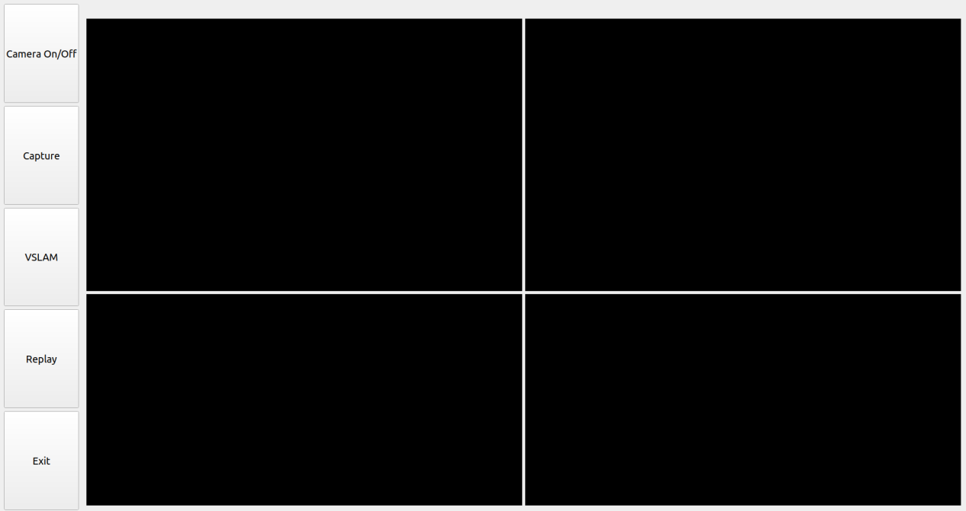
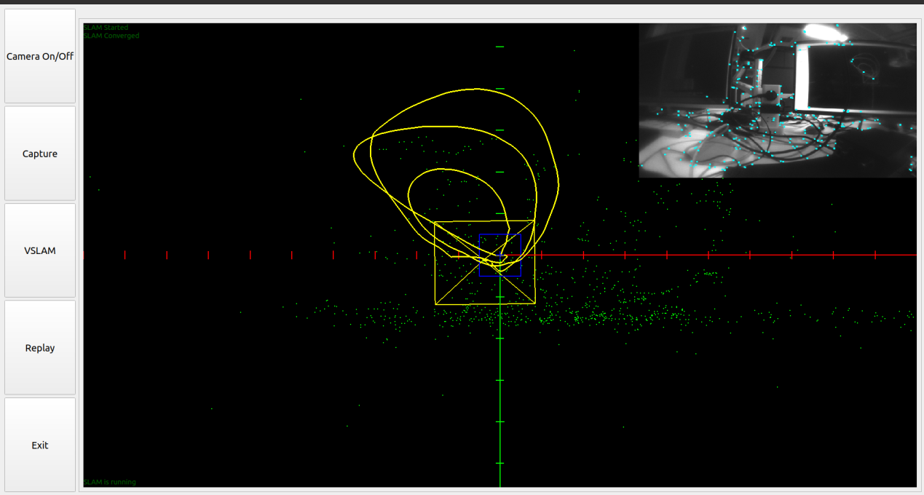
  - Gemba3D_Demo Interface Overview
There are five control buttons on the left side of the interface. Their primary functions are as follows:

Camera on/off: Toggles the camera on or off. The camera is enabled by default when the program starts.

Capture: Captures one frame from each type of camera (including RGB, ToF, Left Fisheye, and Right Fisheye).

VSLAM: Switches to the SLAM interface. Clicking again exits the SLAM interface and returns to the main window.
The SLAM interface displays the device’s real-time spatial trajectory.
The top-right sub-window shows the Left Fisheye camera feed and detected feature points.

Replay: Displays the most recently captured frame across the four main view windows. Click again to exit Replay mode and return to live preview.

Exit: Closes the application

- Gemba3D_Demo Source Code Structure

The Gemba3D_Demo program is developed under Ubuntu using Qt.
Before building the project, ensure that a Qt-based cross-compilation environment is properly configured. Refer to the corresponding setup guide for detailed configuration steps.
The Gemba3D device integrates one stereoPRO module and one IMX258 RGB camera module. The stereoPRO module includes one ToF sensor, two fisheye cameras and one IMU sensor. SLAM navigation and localization are performed using the dual fisheye cameras and IMU module.
The basic structure of the Gemba3D_Demo Qt source code is as follows:

Gemba3D_Demo/
├── Gemba3D_Demo.pro # Project configuration file
├── main.cpp # Main program entry
├── mainwindowPVT.h # Main window header file
├── mainwindowPVT.cpp # Main window class implementation
├── GL3DWidget_QT.hpp # 3D display window header file
├── GL3DWidget_QT.cpp # 3D display window implementation
├── GLWidget.hpp # Display widget header file
├── GLWidget.cpp # Display widget implementation
├── RgbStream.hpp # RGB camera stream header file
├── RgbStream.cpp # RGB camera stream implementation
├── SlamRecorder.hpp # SLAM data processing header file
├── SlamRecorder.cpp # SLAM data processing implementation
├── XvComponent.hpp # stereoPRO camera component header file
├── XvComponent.cpp # stereoPRO camera component implementation
├── Utils.hpp # Utility class header file
├── Utils.cpp # Utility class implementation
├── mainwindowPVT.ui # Main window UI layout file
└── xvComponent.ui # Component window UI layout file

- stereoPRO API and Sample Code

The complete stereoPRO API documentation is available at:
https://hmsfrance.github.io/TestDoc/xvsdk/index.html

The stereoPRO sample codes are located in the following directory on
the Gemba 3D Devic: /usr/share/xvsdk

The corresponding header files can be found at: /usr/include/xvsdk/

The all_stream project contains sample code demonstrating how to
enumerate stereoPRO devices, open all cameras and acquire data
streams.

The demo-api project contains sample code showing how to obtain
IMU data and related information such as 6DoF data.

- Periperal Device API Usage for Gemba3D

Gemba 3D includes several peripheral components, such as buttons,
LED indicators, and a battery gauge.

Sample code can be found in the following directory:
/usr/share/xvsdk/gemba3d-example

The corresponding header file is located at:
/usr/include/gemba3d-sdk.h

The sample code demonstrates how to initialize and retrieve data
from the IMX258 color camera, control the LED indicator (turn it on
or off), read the current battery level and access button input
information.

